**BUILD A PYTHON CODE , ASSUM EYOU GET A TEMPERATURE AND HUMIDITY VALUES GENERATED WITH RANDOM FUNCTION TO A VARIABLE AND WRITE A CONDITION TO CONTINUOUSLY DETECT ALARM IN CASE OF HIGH TEMPERATURE.**

PYTHON CODE:

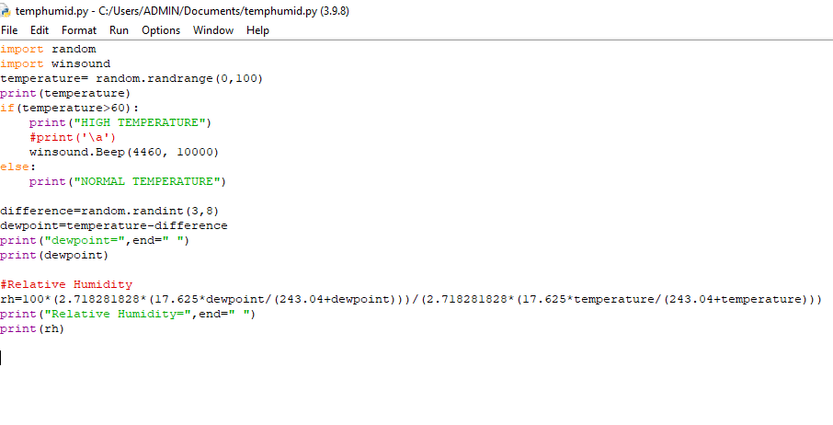

OUTPUT:

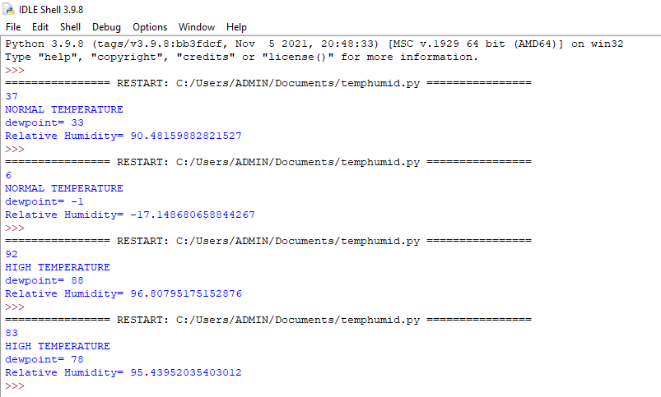

DRIVE LINK(VIDEO LINK):

https://drive.google.com/file/d/1yRD8vI9Zej4rr4ov9R-QHzZp6YnbfwYp/view?usp=sharing